Web Quest
THE YOUTH PROBLEMS

WEB-QUEST ON
THE YOUTH PROBLEMS
Introduction
This Web Quest is devoted to the youth problems. They have become exceptionally acute in the modern world and the youth protection has become a vital necessity for all people.
Task
What types of the youth problems are urgent now? To answer this question you will need to work in small groups and complete tasks and assignments designed by your instructor.
Process
For the lesson on "How to help our young people" the whole class will be divided into several groups. Each group will get one type of the youth problems. Your task will include the following:
A. Pre-class preparation:
- Study Web-based materials. Use links suggested;
- Answer the questions;
- Divide the material between all the team members for presentation in class for the members of others groups;
- Prepare your presentations and reports.
B. In-class activity:
- Report to the whole class what you have learned on the topic for your group activity.
Phase 1 - Background Information
For this lesson, I decided to divide the youth problems into five parts. Each group will need to study only one part and inform the whole class about its major features and subjects.
Phase 2 – Roles
You will be working in teams. It will be up to divide roles in each team. There should be a team leader, who will organize the work and divide the issues within each topic to make sure everything is covered and there is no overlap. All team members are responsible for presenting information in class, regardless their role in pre-class preparation process.
Group 1: Immorality in behavior:
https://scienceforum.ru/2017/article/201703061
http://www.buzzle.com/articles/ Immorality in behavior-effects.html
http://b4tea.com/information/ Immorality in behavior-causes-effects-solutions-for-control/
QUESTIONS:
1. What is an Immorality in behavior?
2. What are the effects of Immorality in behavior?
3. What can people do to stop Immorality in behavior of our world?

Group 2: Alcoholism:
http://kids.mongabay.com/lesson_plans/lisa_algee/ Alcoholism.html
http://www.buzzle.com/articles/facts-about- Alcoholism.html
QUESTIONS:
1. What is Alcoholism?
2. What are the causes and consequences of Alcoholism?
3. What can people do to stop Alcoholism of our world?

Group 3: Drug addiction:
https://www.youtube.com/watch?v=Om42Lppkd9w
http://www. drug addiction.org.uk/
QUESTIONS:
1. What is water drug addiction?
2. What are the reasons for drug addiction?
3. How can you personally help to prevent drug addiction?

Group 4: Crime and suicide:
http://en.wikipedia.org/wiki/ Crime and suicide
https://scienceforum.ru/2017/article/201703061
QUESTIONS:
1. What is crime and suicide?
2. What are the causes and consequences of crime and suicide?
3. What can people do to stop crime and suicide of our world?
Group 5: Internet addiction:
http://www.speakupenglish.org/en/topic/ internet addiction
QUESTIONS:
1. What types of Internet addiction can you name?
2. What are the reasons for each Internet addiction?
3. What can you do to prevent Internet addiction?

Phase 3 - Reaching Consensus
Work in your groups. Discuss the following questions and be ready to participate in the whole class discussion:
1. How can we protect our world and save young people?
2. Should people reject the technological progress?
3. Was life better a hundred years ago?
4. Imagine the situation on our youth in the following years. How can you describe it?
You may do independent Internet search, if it's necessary.
Conclusion
Now you have learned about the youth problems. What problem seemed the most acute for you?

Web Quest
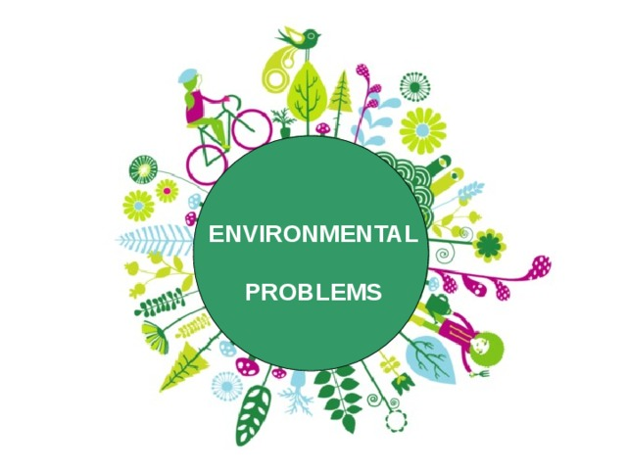

WEBQUEST ON
ENVIRONMENTAL PROBLEMS
Introduction
This Web Quest is devoted to environmental problems. They have become exceptionally acute in the modern world and environmental protection has become a vital necessity for all people.
Task
What types of ecological problems are urgent now? To answer this question you will need to work in small groups and complete tasks and assignments designed by your instructor.
Process
For the lesson on "How to help our planet" the whole class will be divided into several groups. Each group will get one type of ecological problems. Your task will include the following:
A. Pre-class preparation:
- Study Web-based materials. Use links suggested;
- Answer the questions;
- Divide the material between all the team members for presentation in class for the members of others groups;
- Prepare your presentations and reports.
B. In-class activity:
- Report to the whole class what you have learned on the topic for your group activity.
Phase 1 - Background Information
For this lesson I decided to divide environmental problems into five parts. Each group will need to study only one part and inform the whole class about its major features and subjects.
Phase 2 – Roles
You will be working in teams. It will be up to divide roles in each team. There should be a team leader, who will organize the work and divide the issues within each topic to make sure everything is covered and there is no overlap. All team members are responsible for presenting information in class, regardless their role in pre-class preparation process.
Group 1: NOISE POLLUTION:
http://www.pollutionissues.com/Na-Ph/Noise-Pollution.html
http://www.buzzle.com/articles/noise-pollution-effects.html
http://b4tea.com/information/noise-pollution-causes-effects-solutions-for-control/
QUESTIONS:
1. What is a noise pollution?
2. What are the effects of noise pollution?
3. What can people do to stop noise pollution of our environment?

Group 2: DEFORESTATION:
http://kids.mongabay.com/lesson_plans/lisa_algee/deforestation.html
http://www.buzzle.com/articles/facts-about-deforestation.html
QUESTIONS:
1. What is deforestation?
2. What are the causes and consequences of deforestation?
3. What can people do to stop deforestation of our environment?

Group 3: WATER POLLUTION:
https://www.youtube.com/watch?v=Om42Lppkd9w
http://www.water-pollution.org.uk/
QUESTIONS:
1. What is water pollution?
2. What are the reasons for water pollution?
3. How can you personally help to prevent water pollution?

Group 4: AIR POLLUTION:
http://en.wikipedia.org/wiki/Air_pollution
http://environment.nationalgeographic.com/environment/global-warming/pollution-overview/
QUESTIONS:
1. What is air pollution?
2. What are the causes and consequences of air pollution?
3. What can people do to stop deforestation of our environment?

Group 5: NATURAL DISASTERS:
http://environment.nationalgeographic.com/environment/natural-disasters/
http://www.speakupenglish.org/en/topic/natural-disasters
QUESTIONS:
1. What types of natural disasters can you name?
2. What are the reasons for each natural disaster?
3. What can you do to prevent natural disasters?

Phase 3 - Reaching Consensus
Work in your groups. Discuss the following questions and be ready to participate in the whole class discussion:
1. How can we protect our planet and save natural sources?
2. Should people reject the technological progress?
3. Was life better a hundred years ago?
4. Imagine the situation on our planet in the following years. How can you describe it?
You may do independent Internet search, if it's necessary.
Conclusion
Now you have learned about ecological problems. What problem seemed the most acute for you?

